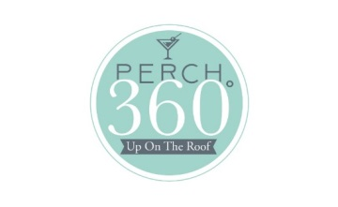

GRILLED CHICKEN CAESAR SALAD $13
Grilled chicken, romaine lettuce, house made croutons & Caesar dressing, fresh shaved parmesan

GRILLED SALMON SALAD $15
Grilled salmon, mustard greens, red leaf, toasted pecans,
feta cheese, honey dijon vinaigrette

TATAKI TUNA SALAD $15
Sesame crusted saku tuna, spinach, watermelon radish, cherry tomatoes,
wakame, orange ginger dressing, sweet soy reduction, crispy wontons

-----------------------------------------------------------------------------------------------------------------------------------
All served with pickle and choice of fries, chips or jicama salad (when available)

CHICKEN SALAD WRAP $11
House made chicken salad, tomato tortilla, apples, walnuts, bacon, avocado, green leaf lettuce, tomato

MAHI CAESAR WRAP $13
Blackened Mahi, romaine lettuce, house made croutons & Caesar dressing, fresh shaved parmesan,
pesto flavored tortilla

CRAB CAKE SANDWICH $15
Maryland style crab cake, flash fried and baked, house made bun, lettuce, tomato, remoulade

TURKEY BLT WRAP $10
Sliced turkey, Neuske’s bacon, lettuce, tomato,
pesto wrap, citrus infused mayonnaise

(ZESTY) CUBAN $11
Slow roasted pork loin, Cappicola ham, sweet and spicy mustard, swiss cheese, dill pickle slices,
house made Cuban bread

BLACK BEAN BURGER $10
Pan seared, pepper jack cheese, lettuce, tomato, roasted red pepper chipotle aioli, house made bun

WYVERN BURGER $14
8 oz. Brisket burger blend, choice of cheese,
lettuce, tomato, fried onions, house made bun

FRESH FISH TACO $11
Cajun grilled catch of the day, guacamole, queso fresco, grilled pineapple, roasted salsa verde,
white corn tortillas

*** Consuming raw or undercooked meats, poultry, seafood, shellfish or eggs may increase your risk of foodborne illness
Prices do not include Tax or Gratuity

